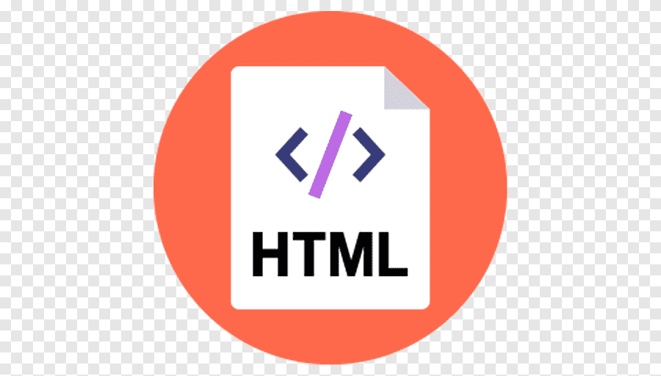

**HTML**

* HTML stands for Hypertext markup language.
* HTML was developed by “Berners Lee” in late,1991.
* HTML is widely used language on web to develop web pages and web application
* HTML element represented by tag so it is also known as tag based language.
* HTML is case insensitive language.
* All HTML documents must save with

“html” and “.htm” extension.

**HTML tag:**

HTML tag starts with ‘<’ and ends with ‘>’.

EX:<html>,<head>,<body>and etc.

**HTML element:**

An HTML element is defined by a start tag, some content and end tag.

<h1>This is Heading</h1>

**HTML attribute:**

* Attribute provide additional information about elements.
* Attributes are always specified in the start

tag.

* Attribute usually come in name/value pairs.

EX:<body bgcolor=”#FFFF00”>

**Types of Tags in HTML**

We have two types of HTML tags.

**Container Tag**

It contains an opening tag and closing tag.

Ex:<h>,<p>,<b>,<i>and etc.

**Empty Tag**

It contains only an opening tag and does not need a closing tag.

Ex:<br>,<hr>,<meta>,<link>and etc.

**Types of Elements**

Block elements

The elements which occupies full width and creates a new link is known block elements.

Ex:h1 to h6, p, div, semantic etc.

Inline block elements

The element which occupies only required width and doesn’t create a new line and accepts width, height, margin and padding properties of CSS is known as inline block elements.

Ex: img, iframe ,button

Inline elements

The elements which occupies only required width and doesn’t create a new line and does not accepts width, height, margin-top, and margin button, padding-top and padding-button, properties of CSS is known as inline elements.

EX: a, span, formatting

**HTML Structure**

<!DOCTYPE html> Tells version of HTML

<HTML> HTML Root Element

<head> Used to contain page HTML metadata

<title>Page Title</title> Title of the HTML page

</head>

<body> Hold content of the HTML

<h2>Heading Content<h2> HTML heading tag

<p>paragraph content</P> HTML paragraph tag

</body>

</html>